Project Development Phase
Model Performance Test

Date | 29 september 2026
Team ID | SWTID-2026-9688
Project Name
  29 september 2026
  SWTID-2026-9688
  Script controlled ACL-escrivted record based on field values
Maximum Marks | 4 mark

Model Performance Testing:
Project team shall fill the following information in model performance testing template.
S.No. | Parameter | Values | Screenshot
 | Model Summary | Salesforce automation setup for Data management using Object, Fields and Reports.  Note : Import Records if data Match Correctly then Records will Created or Else it will Show Error | 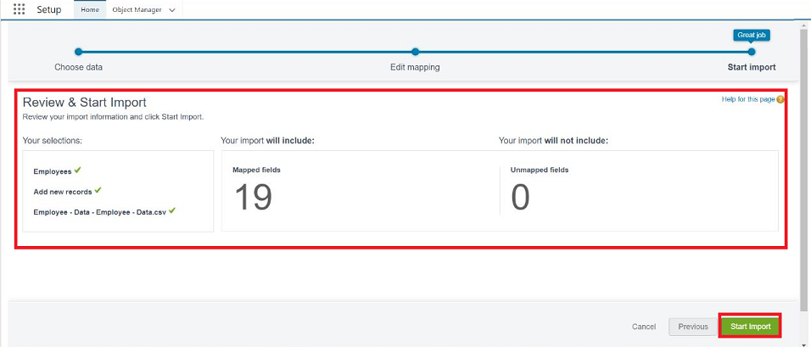
 | Accuracy | Training Accuracy - 98%  Validation Accuracy - 98% | - 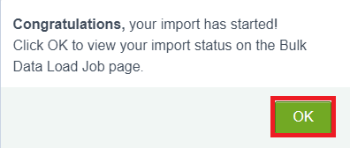
3. | Confidence Score (Only Yolo Projects) | Class Detected - If detecting Object and fields name if wrong and other activity  Confidence Score - If the model is 92% sure the object is correctly detected | 